Student’s name | …………………………………………………….…… | Grade | 2
Subject | Computer | Week No. | 14
Lesson Title | Passwords | Unit
Worksheet No. ( 14 ) (Answer)

Question A: Write the correct name of each part.

User image | Sign-in | Password | Users


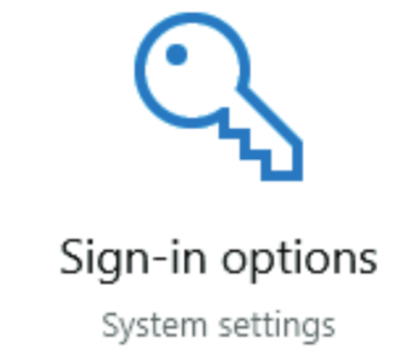

Sign-in
User image
Users
Password
Good Luck

